BOY SCOUT TROOP 42
Nazareth Lutheran Church

TROOP LIBRARY MANUAL
Table of Contents
SUBJECT TAB SECTION
Introduction i
What is the Troop Library
What are your responsibilities
“How-To...” 1
Maintain the merit badge pamphlet library
Run the merit badge pamphlet by-back program
Check materials out and in
Maintain the library
Get additional forms
Change library procedures
List of books in the library 2
Current Merit Badge Books
Out-dated Merit Badge books (to be developed by the librarian)
Other books and pamphlets (to be developed by the librarian)
Checkout sheets 3
Buy-Back program forms 4
Form Originals 5
Introduction

First off, “Thanks!” for taking the position of Troop Librarian. Both the Senior Patrol Leader and the Scoutmaster feel that you can do a good job. The other leaders and Scouts are all counting on you.
The troop library is more than just a collection of pamphlets. It is a source of information about how Scouting is done today and about how Scouting used to be. Some of the materials in the library go back to the early days of Troop 42 – back to World War II. The pictures and language may seem a little dated to our modern eyes but seeing how things used to be can be interesting. Besides, when some adult begins talking about what they had to do as a Scout; you know, the “had to walk 50 miles to summer camp through waist deep snow, uphill both ways” kind of story; you can get out the Boy Scout Handbook from back then and see what the requirements really were.
Your job as Troop Librarian is to care for this collection of materials. Preserving what is already there and adding new materials as needed are a part of the job as is making the materials available to other Scouts and leaders. You are also the key to the troop’s merit badge book buy-back program.
Your specific job duties are:
- Check materials in and out of the library.
- Make sure that we have a current copy of the merit badge pamphlet for all Eagle-required merit badges.
- Recommend new materials for addition to the library.
- Receive used merit badge books from other Scouts and fill out the buy-back form.
- Add materials to the library.

HOW - TO
As Troop Librarian your tasks include checking materials in and out of the library, being the first contact in the merit badge buy-back program, and in maintaining the library by replacing outdated or damaged materials and by adding new materials to the library.
The following procedures were set up to help you in these tasks. Don’t feel, however, that these procedures are the only way to do things or are the best way to do things. If you have a better way talk to the Senior Patrol Leader and the Scoutmaster. If they agree then change the procedure.
CHECKING MATERIALS IN AND OUT
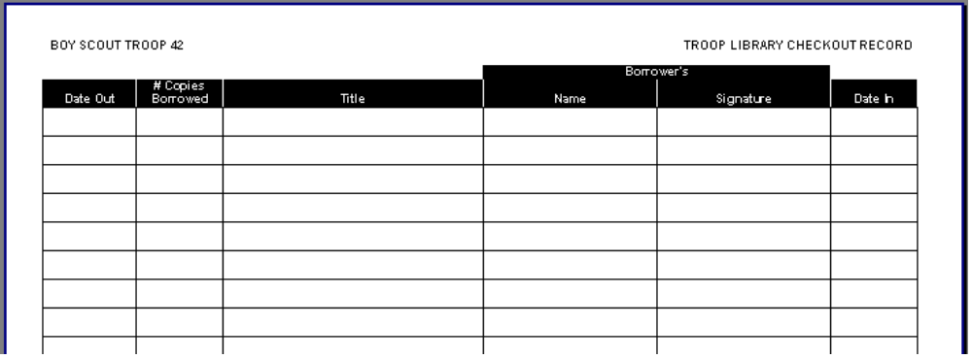
All materials are checked out using the same form. This is what it looks like:
There are blank copies of the form in Section 3 and the original form is in Section4.
Checking materials out of the library is simple. First, print today’s date in the “Date Out” column. Then print the number of copies of that item borrowed in the “# Copies Borrowed” column. Most of the time people will only check out one copy of an item but sometimes (like for songbooks) they might need extra copies. Print the title in the “Title” column, print the borrower’s name in the “Name” column, and have them sign the “Signature” column. That’s all there is to it!
Checking in materials is even easier. To check an item in just print the date it was brought back in the “Date In” column and put the item back in the library.
Damaged or Lost Materials
Sometimes library materials will get damaged or lost while they are loaned out. If this happens go ahead and check the item in by writing the date returned or if the item was lost write the word “lost” and the date reported and report the loss or damage to the Scoutmaster. Usually the troop will just replace the item without any penalty but that is the Scoutmaster’s decision.
MERIT BADGE PAMPHLET BUY-BACK PROGRAM
As you know, the troop will buy used merit badge pamphlets at half-price. One of your responsibilities is to handle this program for the troop. The way the program works is that a Scout will bring his used merit badge pamphlets to you. You will help him fill out the Buy-Back form and then give it to him. It is his responsibility to take the form to either the troop treasurer to credit his troop account or to the advancement chairman if he wants a replacement book.
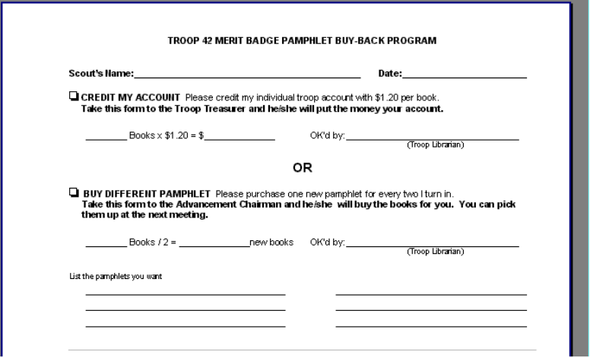
This is the buy-back form:
When a Scout want to turn in merit badge pamphlets he brings them to you. You will take a blank form and print in the Scout’s name and the date. Ask the Scout if he wants a credit to his troop account or if he wants the troop to buy new pamphlets for him.
If the Scout wants a credit to his troop account you fill out the top section. Check the box beside “Credit my Account”. Write the number of books being turned in on the line in front of books and calculate the total credit by multiplying the number of books by the current credit. Then sign the form where it says “OK’d by”, and give the completed form to the Scout.
If the Scout wants the troop to buy new merit badge pamphlets for him check the box beside “Buy Different Pamphlets”. Count the number of pamphlets being turned in and divide by 2 to figure the number of new pamphlets the troop should buy. Ask the Scout which pamphlets he wants, write the names on the lines, sign the form beside “OK’d By”, and give the form to the Scout.
Each form can only be used for a credit to the Scout’s troop account or for purchase of new merit badge pamphlets - not for both. If the Scout wants to split his pamphlets between both options then you will need to fill out two forms. If the Scout only has one pamphlet he must have it credited to his account.
MAINTAINING THE LIBRARY
Eagle-Required Merit Badge Pamphlets The troop wants to have at least one copy of the merit badge pamphlet for all Eagle-required merit badges. One of your first responsibilities is to ensure that we are fulfilling this commitment. If there are pamphlets missing you need to talk to the Scoutmaster about getting them replaced.
Replacing Worn-Out Items Eventually all of the materials in the library will need to be replaced - especially merit badge pamphlets which get the most use. When you think an item is worn beyond repair you need to decide if it should be replaced. First, you need to see if there are other copies in the library. If we have other copies it may not be necessary to buy a replacement unless the item is used a lot. Then second question, of course, is how often the item is used. Here’s where the old check-out sheets can help. If you decide that the troop should buy a replacement you need to tell the Scoutmaster that you recommend buying a replacement. If the Scoutmaster agrees then tell the Advancement Chairperson that the troop needs to buy the item. The Advancement Chairperson will buy the item and give it to you to be put into the library. The old item should be destroyed. Be sure to mark the replacement as troop property and update the list of materials before putting it into the library.
Out-of-Date Materials The Boy Scouts of America changes materials from time to time as new program elements are added or as requirements change. When this happens the troop needs to update the library. The biggest problem is finding out when these changes happen. Your best source of information is the District Roundtable. These meetings happen once a month and there are sessions for adult leaders and for the Senior Patrol Leader. Remind your SPL of the need to attend these meetings and to be sure to tell you of changes to the literature. When a change does happen you need to determine how many items are effected and decide what new items should be purchased and how many of each type are needed. Make your recommendation to the Scoutmaster. The out-of-date materials are not destroyed but should be put with other obsolete materials. Again, don’t forget to make the replacements as troop property and update the list of materials before putting them in the library.
New Materials
Every now and then BSA will introduce a new merit badge subject or will publish a new reference book. You are responsible for reviewing the new materials and recommending whether the troop should purchase a copy. To make the job easier you only need make recommendations for the items you think we should buy. If you don’t think we need a copy you don’t have to make a recommendation.
GETTING ADDITIONAL FORMS
When you get near the end of the blank forms then you need to get more. The original forms are kept in Section 5. You can ask the Scoutmaster or Advancement Chairperson to make the copies for you unless you have access to a copy machine.
There are also copies of the forms and of this document on the diskette included in the front of this folder in case you want to print copies or make changes to them. All of the documents were created using Microsoft Word for Windows 95 (Word 7.0a).
CHANGING LIBRARY FORMS AND PROCEDURES
This manual, the form, and the procedures are not the final word in troop libraries. They were put together simply to give us all a place to start. As you become more familiar with running the library you will see better ways to do things. Don’t be afraid to recommend changes – that’s part of your job as Librarian. When you develop a better method talk it over with your Scoutmaster and then, if he agrees, GO FOR IT!
NAME OF ITEM | COPYRIGHT/EDITION/REVISION
Architecture | 1995 Printing of the 1995 edition
Athletics | 1971 Printing of the 1943 edition
Basketry | 1968 Edition
Camping | 1988 Printing of the 1984 revision
Chemistry | 1994 Printing of the 1992 edition
Citizenship in the Community | 1995 Printing of the 1993 revision
Citizenship in the Nation | 1995 Printing of the 1993 revision
Citizenship in the Nation | 1995 Printing of the 1993 revision
Citizenship in the Nation | 1995 Printing of the 1993 revision
Citizenship in the World | 1995 Revision of the 1993 edition
Citizenship in the World | 1995 Revision of the 1993 edition
Citizenship in the World | 1995 Revision of the 1993 edition
Coin Collecting | 1975 Printing of the 1975 revision
Communications | 1995 Printing of the 1992 edition
Cooking | 1995 Printing of the 1986 edition
Cycling | 1984 Printing of the 1984 revision
Cycling | 1985 Printing of the 1984 revision
Electricity | 1991 Edition
Environmental Science | 1996 Printing of the 1983 revision
Fire Safety | 1995 Edition
Fire Safety | 1995 Edition
Fire Safety | 1995 Edition
First Aid | 1995 Printing of the 1995 edition
Horsemanship | 1995 Printing of the 1986 revision
Indian Lore | 1963 Printing of the 1959 edition
Landscape Architecture | 1980 Printing of the 1969 edition
Personal Management | 1996 Printing of the 1996 revision
Sports | 1972 Printing of the 1972 edition
Sports | 1972 Printing of the 1972 edition
Sports | 1983 Printing of the 1972 edition
Sports | 1994 Printing of the 1972 edition
Swimming | 1995 Printing of the 1993 edition
Truck Transportation | 1973 Printing of the 1973 edition
Truck Transportation | 1973 Printing of the 1973 edition
Truck Transportation | 1973 Printing of the 1973 edition
Truck Transportation | 1973 Printing of the 1973 edition
Wilderness Survival | 1984 Printing of the 1984 revision
Wilderness Survival | 1984 Printing of the 1984 revision
Wilderness Survival | 1987 Printing of the 1984 revision
Woodwork | 1992 Printing of the 1970 edition

 |  |  | Borrower’s
Date Out | Copies | Title | Name | Signature | Date In

TROOP 42 MERIT BADGE PAMPHLET BUY-BACK PROGRAM
Scout’s Name: Date:
o CREDIT MY ACCOUNT Please credit my individual troop account with $1.20 per book.
Take this form to the Troop Treasurer and he/she will put the money your account.
________ Books x $1.20 = $______________ OK’d by:
(Troop Librarian)
OR
o BUY DIFFERENT PAMPHLETS Please purchase one new pamphlet for every two I turn in.
Take this form to the Advancement Chairman and he/she will buy the books for you. You can pick them up at the next meeting.
________ Books / 2 = ______________new books OK’d by:
(Troop Librarian)
List the pamphlets you want
TROOP 42 MERIT BADGE PAMPHLET BUY-BACK PROGRAM
Scout’s Name: Date:
o CREDIT MY ACCOUNT Please credit my individual troop account with $1.20 per book.
Take this form to the Troop Treasurer and he/she will put the money your account.
________ Books x $1.20 = $______________ OK’d by:
(Troop Librarian)
OR
o BUY DIFFERENT PAMPHLETS Please purchase one new pamphlet for every two I turn in.
Take this form to the Advancement Chairman and he/she will buy the books for you. You can pick them up at the next meeting.
________ Books / 2 = ______________new books OK’d by:
(Troop Librarian)
List the pamphlets you want

